Israel Travel Guide
Are you extending your stay in Israel after Birthright?
Does your little brother have an upcoming Bar Mitzvah in Jerusalem?
Are you going on a MASA or ONWARD program for a few months in Israel?
If so, you are in luck because our Israel Fellow who is a licensed tour guide, compiled is a list of things you can do all over Israel.

Jerusalem

Places to see/sites to visit
THE HOLY CITY.
The sites to see in Jerusalem will be determined by how many times have you been there before. First timers will visit completely different places then someone who has been there 8 times before.
The main things to see will be all 4 quarters (Jewish, Muslim, Christian and Armenian) of the old city of Jerusalem. Remember to visit the 3 holy sites for the 3 religions: The Western Wall, Temple Mount, and the Church of the Holy Sepulchre. A quick search on Google will help you find free tour companies that will take you on a 2-3 hour tour around the old city with a licensed tour guide (highly recommended).
Another place you must see is The City of David. It’s one of the most fascinating archaeological sites you will find in Israel. The site shows archaeological findings from the prehistoric period, the destruction of the First Temple, the rebirth of the Second Temple, and the evidence supporting the existence of various biblical characters. Was it really the palace of King David? You will have to go there to find out!
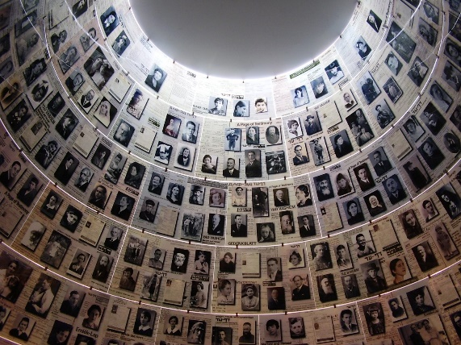
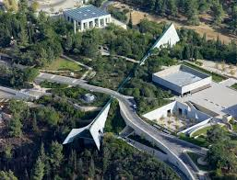
You also need to visit Yad VaShem, Israel's official memorial for the victims of the Holocaust. This is one of the most important places you will visit in Israel. You can spend 2-3 hours visiting and another 4 days going through all the documents and records this place has to offer. Both admission and a guided tour of the museum are free.

For those of you who are more experienced, you can visit: Nachlaot, Nahalat Shiv'a, Mishkenot Sha’ananim, Mount Zion, Mount Scopus, Mount of Olives, Israel Museum, Museum on the Seam, Tower of David (not the same thing as the city of David), Museum for Islamic Art, the German Colony, Jerusalem railway station, Gazelle Valley, The Tisch Family Zoological Gardens (Jerusalem Biblical Zoo), Ein Karem.

Food
If you already visited Israel, you would notice that we did not mention one of the most amazing places in Jerusalem. Machne Yehuda! Machne Yehuda is the largest and most incredible market in the west side of the city! You will find everything in this market from simple street food to gourmet restaurants, savory and sweet treats, comfort food and fast food, juice stands and a pub… long story short, if you want to find good food, this is the place for you.
If you are in the old city, you can find great hummus, kabab, baklava and much more at the Muslim Market in the Christian and Muslim quarters. If you are looking for kosher food, you will find a variety of options in the Jewish Quarter.

Entertainment
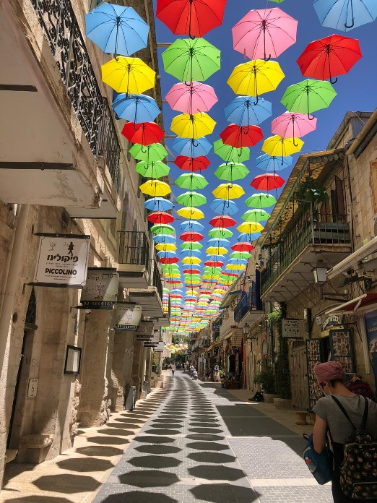
Café Shalva: Cafe Shalva is a boutique café that is also an equal-opportunity work setting where an inclusive staff work as managers, waiters, and hosts. The cafe’s menu and management were developed in partnership with elite culinary establishments, Derech Hagefen in Beit Zayit and Café Itamar. Its interior design is artistically crafted to inspire newfound understandings of inclusion and acceptance.
Yoel Moshe Salomon Street: If you will ever google pictures of Jerusalem you will see the old city, the dome of the rock, the western wall and the old city walls. You will also find a picture of a beautiful street with colorful umbrellas hanging over the people walking down the street and making the street a big tourist attraction.
Segway Tour in Jerusalem: many tourist companies are offering Segway tours around the old and modern city. They will provide you with a Segway, helmet, and a tour guide for few hours.

Fun Facts
All structures in Jerusalem (public and private) must be built or covered by “Jerusalem stone.” Jerusalem stone is the name of various types of pale limestone, dolomite, and dolomitic limestone.

Tel Aviv-Jaffa

Places to see/sites to visit
When visiting the most vibrant city in the world, there are several things to focus on: night life, the beach, food, history, art, and architecture.
The Carmel Market: the largest market in Tel Aviv. A great shuk (market) where you can find everything from clothing to spices, and fruit to electronics. The best way to experience the market is to take a food tasting tour. Afterwards, you can just walk around the shuk and “Kerem HaTimanim” and experience all the uniqueness of that area. The Carmel Market is less than a 10 minute walk to the beach.
Another amazing market is the Flea Market. Completely different then the Carmel Market, this market is full of antique shops, old jeans stands, boutique furniture, local artists, and designer shops. You can walk through the small alleys of the market for hours in the morning, get some cold fresh juice, eat some hummus, go to the Jaffa Port and the old city, and come back to the Flea Market during the evening when all the shops are closed and dozens of bars and restaurants are taking over the market. The vibes are completely different!
The last area you must see and visit in Tel Aviv is Hertzl St. and Rothschild Blvd. Hertzl St. was the first street built in Tel Aviv and Rothschild Blvd. is the second. In those two streets, you can find a lot of historic buildings (like the independence hall), architecture symbols, and art galleries. Like most places in this city, you can find a variety of restaurants and coffee places. At night time, this is one of the main party areas with night clubs and bars all around.
If it is not your first time in Tel Aviv or you have many days to spend in the city, you can visit: Bialik Square, Rabin Square, Tel Aviv Port, The Yarkon Park, Eretz Israel Museum, Tel Aviv Museum of Art, Sarona, Florentin, and Shuk Levinsky.

Food
Hummus Abu Hassan: many people (you can almost say everyone) say that this small hummus place in Jaffa is the B-E-S-T hummus in Israel! The only way to really know it is to go there and try it yourself. If you are going on Friday at noon, you will probably have to wait 30-50 minutes until you get a table. (Not Kosher certified).
In Tel Aviv, you can find all types of food! Israeli Street food, Japanese, Indian, Mexican, Vegan, Italian, Chinese, Thai, Yemeni, Turkish, American, Sea Food, and so much more! The only tip you need is do not be afraid to try new things! Anywhere you will look you will find good food in this city.
Coffee! Yes, yes, Aroma. We all know Aroma is one of the most popular coffee places in Israel, but Tel Aviv has a lot of awesome coffee places!

Entertainment
Nalaga'at is a nonprofit organization established, and the first theater company in the world whose performers are all deaf-blind (dual disability). The Nalaga’at Organization's focus is to raise awareness of the needs of the deaf-blind population in Israel and worldwide. In the center, you can also find Kapish Event Center where deaf and hearing-impaired waiters invite the guests to communicate and order their coffee and sandwich in sign language; Blackout Restaurant is another cool venue where blind and visually-impaired waiters accompany the guests to a meal in total darkness.
Tel Aviv Pride Parade: Tel Aviv hosts an annual pride parade, attracting more than 260,000 people, making it the 4th largest LGBT pride event in world! The Pride Week in Tel Aviv is a huge, weeklong party that attracts thousands of people from all over the world.

Fun Facts
In 2017, the British online publisher “The Independent” declared Tel Aviv as the vegan capital of the world!

Center

Places to see/sites to visit
The “Center” of Israel is usually considered as the area between Gedera to Hedera, but of course you can “stretch” it a few miles here and there. The center is very close to the coast line of Israel, which means the climate is very hot and humid during the summer and cold, windy, and wet in the winter. Although it is the most populated area in the country, you can still find a lot of parks and nature resorts to visit. While going around the area, it is highly recommended to visit some archeological sites.
Caesarea is one of the most famous archeological sites in the center of Israel. Caesarea is an ancient city that was built under Herod the Great as a gift to the Roman Emperor, Augustus, and named after him (the world for emperor in Hebrew is Caesar). The city served as the provincial capital of Roman Judea. Today you can visit the amazing national park and see the remaining of what was one of the most impressive ancient Roman cities in the area.
The beaches of Netanya are considered by many to be the most beautiful beaches in Israel. It is perfect if you want to step away from all the noise and people in Tel Aviv and go to a quieter beach. While you’re there, you can also visit the Iris Reserve (during January-February).
Biet Guvrin is one of the “secrets” that only Israelis are aware of. Beit Guvrin-Marsha National Park is the heart of "The Land of Thousand Caves". The park presents ancient architectural wonder - countless caves designed for a wide variety of uses, a complete Roman amphitheater, and impressive remains of a fortress and a Crusader church. The National Park is rich in many species of Mediterranean animals and plants.

Food
The Ella Valley is located north to Beit Guvrin, and you can find many boutique cheesemakers and wineries. The Ella Valley is very similar to Napa Valley when it comes to the views and the climate.
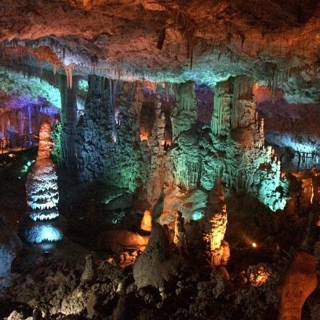
If you want to have a local culinary experience, Ramla Market is the place to go! You will find: Fruits and vegetables, a bakery, pickles, burks, clothing, bags, footwear, sweets, curtains, maps, furniture, houseware, spices, and so much more! All of the Mediterranean/Jewish food you can think can be found there! You will need to know some words in Hebrew to bargain properly.

Entertainment
Abseiling is very common in every area you visit in Israel. A short search online will give you dozens of companies you can schedule abseiling with whenever you want!
Stalactite Cave Nature Reserve is unique for its dense concentration of stalactites and other cave formations. This is an amazing opportunity to see a rare, natural phenomenon only 30 minutes from Jerusalem!

Fun Facts
80% of Israel’s population live in the center of the country (in between Jerusalem and Tel Aviv).

North

Places to see/sites to visit
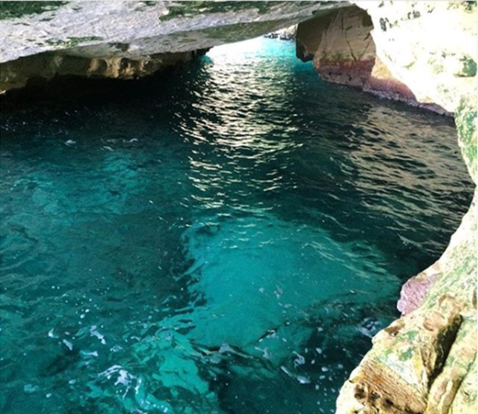
Haifa-Acre-Rosh HaNikra are three sites you can see all on the same day with only a 25-30 minute drive between each place. Haifa is the big city in the northern district and is notoriously beautiful! You can visit the Baháʼí World Centre, Stella Maris, the German Colony, art and history museums, and even do nature hikes inside the city! You can drive or even take public transportation to Acre and start to walk around the beautiful street of the old city. The Knights' Halls are halls that the Crusaders used when they conquered the country and made Acre their capital. The city of Acre made an entire museum where you can learn about the Crusaders, their culture, stories, fights, and what happened to them in the holy land. From there, you can continue to Rosh HaNikra grottoes, a place where the mountains meet the sea. The Rosh HaNikra cliff is made of chalk and formed after thousand years of waves crashing against the soft chalk rock. The result is beautiful white caves with crystal clear water.
After visiting the north coast line, you can move east and start to discover the inland of the north. One of the big cities in the center of the north is Nazareth. Nazareth is the biggest Arab city in Israel, with a mixed population of Muslims and Christians. Nazareth is one of the most important cities in Christianity making it a big tourist attraction! With beautiful churches, great restaurants, incredible coffee, amazing markets (not on Sunday) and wonderful vibes.
Another, very important city, a city with a centuries-old Jewish community is Tzfat. Sixteenth-century prosperity is the time when the Jewish community was at its peak. All the major rabbis of the time were in Tzfat. That was also the time the city became a center of Kabbalah. Today you can visit the old synagogues, see Jewish art shops, try some of Israel’s most famous cheese, and enjoy the pastoral view and atmosphere.
When standing in Tzfat and looking to the east, you will see the sea. Not the Mediterranean, and honestly, it’s not really a sea. You will be looking at the Sea of Galilee (Kinneret), which is a lake (shhhh don’t tell anyone ). The Kinneret has so many things to do, sites to visit, and places to see: Tiberias, Magrase Nature Reserve, Luna Gal water park, sailing, water skiing, and other water sports.
More places to discover in the north: Bet She'arim National Park, the Gilboa Mountain, the Sahne (Gan HaShlosha National Park), Pki’in, Hahula Valley, Rosh Pina, Mount Meron, and Metula.

Food
When traveling in the Galilee area, you will come across many different and unique cultures and ethnicities. Two of those are the Druze and the Circassians. While traveling around, you should definitely visit a Druze or/and Circassians villages. There are many families that will take you into their home, feed you, and share their story and culture with you. This is a once in a lifetime experience!
Just like in the center district, you can find many boutique cheesemakers and wineries and also really high-quality olive oil.

Entertainment
If you want to hike, Sea to Sea (Yam El Yam- ים אל ים) is a great option! The Sea to Sea trail crosses the country from the Mediterranean Sea to the Sea of Galilee. Normally, people complete it in 4 days. If you are a professional hiker, you can do it in 3 or even 2 days. Make sure you know where you can refill your water bottle and get enough food for the hole trail.
Another very cool activity is kayaking, Jeep tours, and Bike rides. Along the north part of the Jordan River, there are few kayaking spots. You can choose between 1-6 people on each boat and go kayaking for 40-60 minutes. Jeep and All-terrain vehicle tours are very popular in the north. Wherever you drive, you will see advertisements for different kinds of tours. If you have not had enough biking in Davis, you can go on a beautiful bike ride in Agmon HaHula. At the right time of year, you can see over half a billion birds crossing through the northern skies of the Galilee.

Fun Facts
The majority of the population in the northern district are Arabs (55%) who practice four different religious.

South

Places to see/sites to visit
In Israel, the south is also referred to as the Negev, the desert. The Negev is a wonderful place to hike, experience some quiet time, meditate, and escape from the big cities. You can find hundreds of hiking trails of different levels, from easy 40 minutes trails to weeklong extreme trails. You must be aware of your hiking ability. Do not hike on a trail that is not suitable for you. When hiking in Israel and in the south specifically, you have to make sure you bring a lot of water (3 liters recommended) with you, hat, closed toe shoes, and sunscreen. Make sure someone knows where you are hiking and when you will be back from the hike.
Three cities you should visit are Be’er Sheva, Mitzpe Ramon, and Eilat. Each one of those cities can offer you a different experience. Be’er Sheva is the biggest city in the Negev! The city has been going through massive gentrification in the past few years and becoming a young, academic city. Ben Gurion University (BGU) has a lot to do with this process. A lot of young students are moving into this city for school and stay there after graduation. You can visit the old city of Be’er Sheva, shop in the city shuk and in the biggest mall in the country, see the university and enjoy the restaurants and night life.
Mitzpe Ramon is a small town right in the middle of the Negev at the edge of the Ramon Crater (Makhtesh). This small place is one of the most peaceful and quiet places in Israel. This place is great if you are looking for something more calm and spiritual. You can find many hiking trails around the town, discover a rare geological phenomenon, take tours to learn about the desert animal and plants, meditation, art and dance classes, and art galleries.
Eilat is the most southern city in Israel! The focus in this city is tourism so you know you have a lot of things to do there. From scuba diving and snorkeling to hiking in the beautiful mountains surrounding the city, swimming with dolphins, visiting the Underwater Observatory Park, enjoying the lovely hot weather while walking along the coast line of the red sea, and of course shopping in the only tax-free city in Israel.
The Dead Sea and Masada: you cannot visit Israel without covering your body with mud and floating in the Dead Sea! The lowest point in the world! The Dead Sea is named the Dead Sea because nothing can grow or live in the water. Why? The Dead Sea is a salt water basin, but the water has no exit except evaporating and leaving the small presence of salt behind. Take that and multiply it by tens of thousands of years and a lot of salt is left behind that turns the water salty! How much salty you ask? 33% of the sea is salt! Just to compare, the Pacific Ocean salinity is 3.5 %. When you visit the Dead Sea, you can also go and visit Masada! Masada is one of the most famous national parks in the country. It is known for the palaces Herod the Great built and the siege of Masada the Romans laid during the First Jewish–Roman War. Masada is one of the most important archeological sites ever discovered in Israel.
Other places in the south: Ein Ovdat, Sde Boker, Rahat, The Arava, Neot HaKikar, Ein Gedi, Timna Park, Yotvata (Kibbutz).

Food
Bedouin hospitality: The Negev Bedouin are traditionally, pastoral, nomadic Arab tribes (Bedouin) living in the Negev region of Israel. The Bedouin tribes adhere to Islam. There are a lot of Bedouin “villages” that offer the “Bedouin experience” and they are known for their amazing hospitality. You can stay there overnight, sleep in a Bedouin tent, and learn about their unique lifestyle and culture. If you do not have too much time you can also visit just for lunch or dinner. You will not regret it!

Entertainment
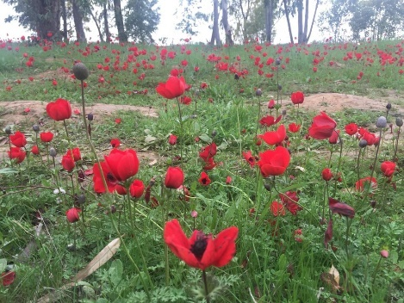
Darom Adom- means Red South. During the month of February, the Anemone flower blossom in the northern part of the Negev region and you can go and see the beautiful red fields that go for miles!
Midburn: the Israeli version of the Burning Man festival in Nevada. The Midburn is a 6-day event held in the Negev near the Kibutz Sde Boker. The name comes from the Hebrew word for "desert" (מידבר midbar) and the English word "burn". Some say the “Mid” is also for Middle East Burning Man.
African Hebrew Israelites of Jerusalem: is a spiritual group now mainly based in Dimona whose members believe they are descended from the Twelve Tribes of Israel. Most of the members of this community come from Chicago, Illinois and moved to Israel in the 1960’s. The group maintains a vegan diet, abstinence from alcohol, other than the naturally fermented wine which they make themselves, as well as abstinence from both illegal and pharmaceutical drugs. You can schedule a tour with someone from the community in their neighborhood to learn more about their unique way of life.

Fun Facts
The Negev makes up 60% of Israel and only 8% of the population live there.

General Things to Know

Shabbat:
A lot of places are closed on Friday afternoon through Saturday since it is Shabbat, the holy day for the Jews. In Israel, the weekend is Friday and Saturday. You can still find places that will be open, but there will be no public transportation. If you are flying into Israel between Friday afternoon to Saturday evening, your only way to get out of the airport is if someone is picking you up, you pre-booked a shuttle, or a taxi.

Money
The currency in Israel is NIS (New Israeli Shekel). The Shekel is pretty stable and it’s usually 1:3.5, meaning one USD is 3.5~ Shekels. If you are planning on drawing cash money out of the ATM, make sure you ATM pin code is only 4 digits! The ATMs in Israel cannot accept more or less than 4 digits.
The prices printed on a menu or price tags already include tax. When a price is present on a menu, tag or anywhere else, the tax has already been added, and you will see the final price you need to pay.
HOW TO TIP? Tipping in Israel is 10% minimum required! If you enjoyed your service, it’s common to give 15-18% and if it was outstanding, give as much as you want. If you want to leave your tip in cash, you pay your bill, get the change/receipt, and then put down the tip and leave. If you want to leave your tip by card, you must tell the waiter/waitress before they charge your card! You need to be specific about the amount you are giving, how much, and if you are referring to the percent or the Shekels.
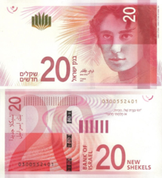
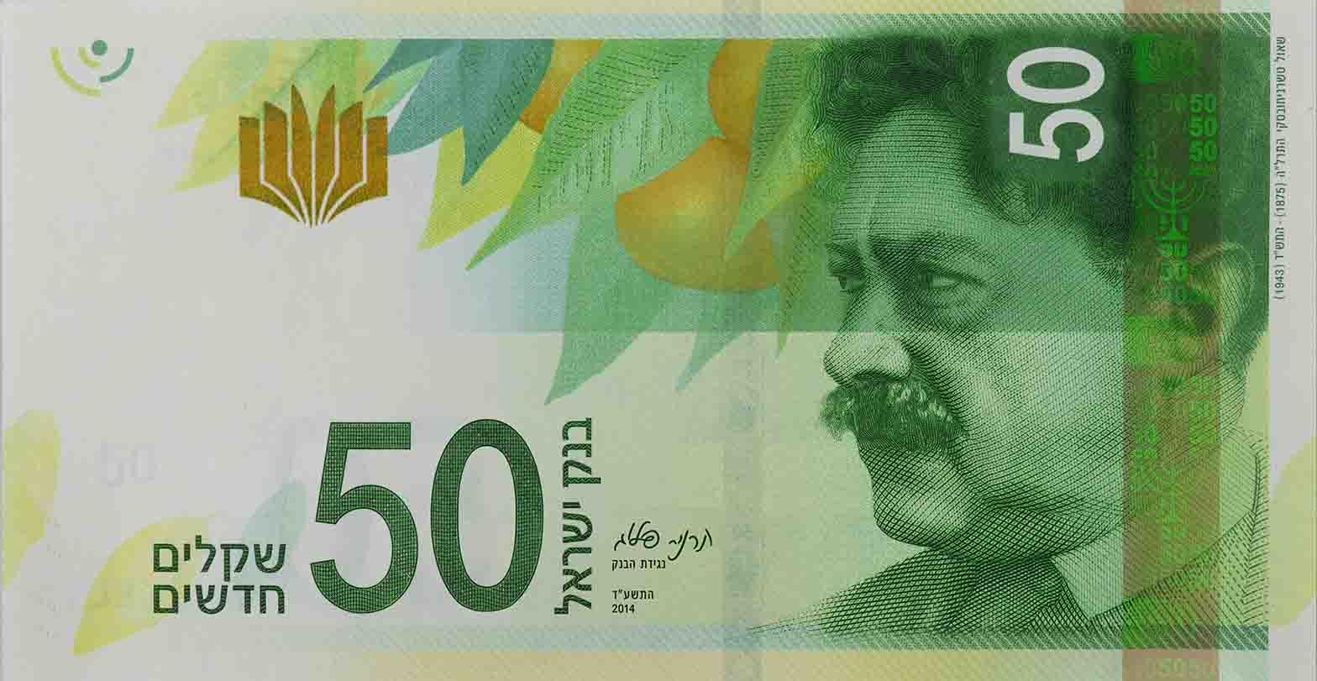
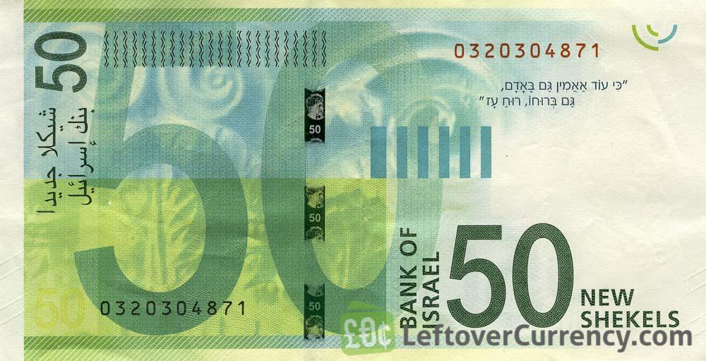
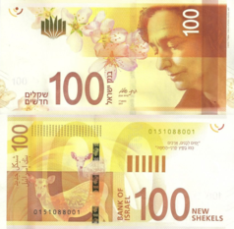
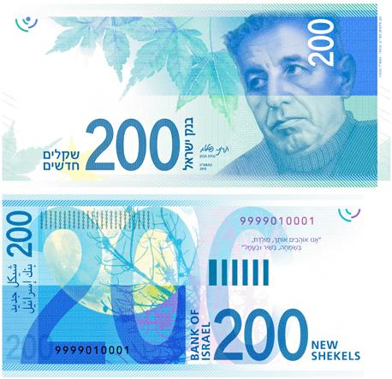
This is what the money looks like:
20₪ 50₪ 100₪ 200₪
0.50₪ 0.10₪ 0.05₪ 0.01₪
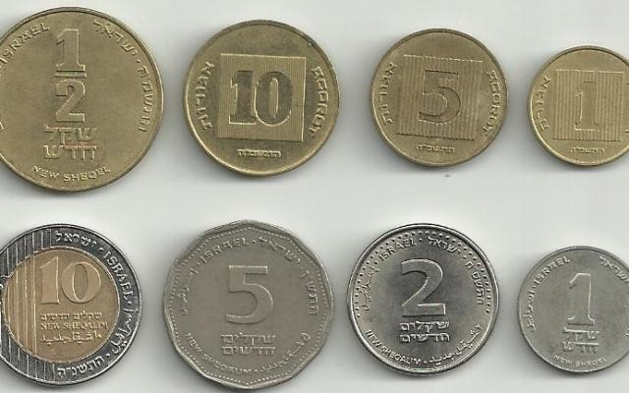
Agorot (the equivalent to cents)

One Shekel have 100 Agorot

10₪ 5₪ 2₪ 1₪

Electricity
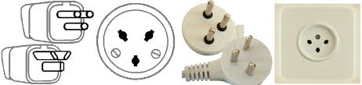
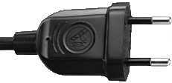
Electrical adapters (220 volts AC, single phase, 50 cycles)
When getting an adapter, make sure it moderates the volts as well. Americans electrical adapters are 110 volts. Not all American electronics will work in Israel.

Security
Israel takes its security very, very, very, VERY seriously! What does this mean for you? Just be aware of your bags and your space. If you see something weird, tell a police officer or a security guard. Do not leave your bags unattended. When going into big places like malls and bus stations, there will be a security guard and sometimes they will ask to check your bags. That is normal.
Airport security can take a very long time! There are many precautions that you will see that are different than US airport security (questioning passengers, checking bags if needed, armed guards, etc.) and many other precautions that you do not see. Arrive to the airport 3 hours before your flight and start the security process. You cannot fill bottles with water before boarding when flying to the US.

Cultural Gaps
Few things to know that will help you cope with Israelis and the Israeli mentality.
Personal space: there is none. Israelis do not believe in personal space at all (pre-corona). No one stands in lines, and they are very close to one another.
People yell all the time. Israelis love to be heard! To make sure everyone hears them, they speak very loudly. Do not worry, you can ask nicely to lower their voice.
No splitting bills! When sitting in a restaurant, you cannot split a bill amongst different people. There is one and you need to remember who ordered what and how much your order cost.
If you want to use public transportation (good luck), you can use the app “moovit” (you will need phone data or Wi-Fi). Public transportation does not operate during Shabbat.
It's acceptable to bargain in the market (shuk), but it not acceptable in shops, cafes, or restaurants.

Free Tours
There are many free tours companies that you can find online that will take you on free tours in Jerusalem, Tel Aviv, and Jaffa. At the end of the tour you are expected to tip the tour guide as much as you fill like. You can also find a lot of payed tours to destinations all over the country.

Helpful Links
Here is a list of YouTube links that you might find useful:
Beach Culture
https://www.youtube.com/watch?v=zPvveYRetNg
Food
https://www.youtube.com/watch?v=2KnhceNHxqs
Food 2 (Tel Aviv)
https://www.youtube.com/watch?v=4gGpsp_zFP8
Hiking
Part 1
https://www.youtube.com/watch?v=e_ET4EFiYJQ
Part 2
https://www.youtube.com/watch?v=mULqOQx_Oys
Part 3
https://www.youtube.com/watch?v=NIXnyOroUPc
Funny Monday - Israeli standup in English
https://www.facebook.com/funnymondayisrael/
Dating
https://www.youtube.com/watch?v=yk9cenmvips
Speaking Hebrew
Part 1 (Natalie Portman)
https://www.youtube.com/watch?v=CeBirl8WxMI
Part 2
https://www.youtube.com/watch?v=nyUNaeDcGNE
And of course, we must have Gal Gadot telling us about Tel Aviv!
https://www.youtube.com/watch?v=lAAqAZNnJXw
HAVE FUN IN ISRAEL!

